How to add another powerline adapter to the existing powerline network?
Step 1: Plug the new adapter into wall receptacle near PA6.
Step 2: Press the pair button on PA6. The PLC LED indicator blinks.
Step 3: Press the pair button on the new adapter. The PLC LED indicator blinks.
When the PLC LED indicators on both adapters turn solid on, they succeed in pairing with each other.
Step 4: Open bowser and enter plc.tendawifi.com in address bar to login the setup page.


Step 5: Choose powerline list. And pay attention to “PLC Device List”.
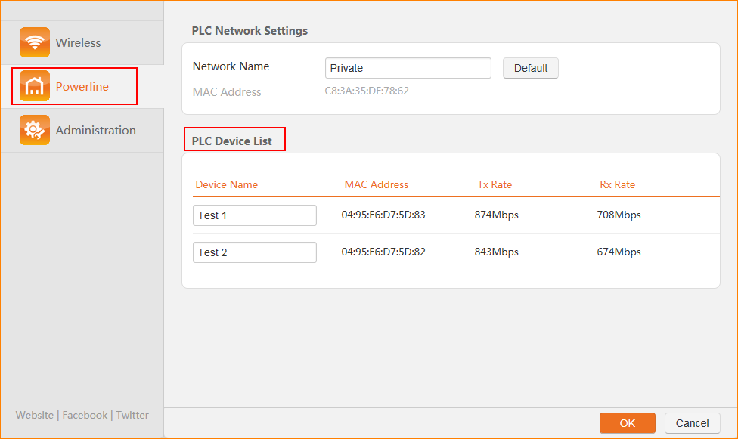
Note: The PLC Device List displays all the other devices in the home powerline network of PA6.

